|  |  |  |
| --- | --- | --- |
| F:\Master\بسم الله الرحمن الرحيم\New folder\061802120774.jpg | ***Zagazig University***  ***Faculty of Computers and Informatics Computer Science Department***  **Project ID: GP_2501** | F:\Master\بسم الله الرحمن الرحيم\New folder\121511592326.gif |

***AI-POWERED HEALTH ASSISTANT FOR RAPID DIAGNOSIS OF WOUNDS, BURNS,***

***AND SKIN INFECTIONS***

***BY***

1. **Dina Maher Sabry Mohamed**
2. **Donia Hesham Abdel-Hamid Hassan**
3. **Mohamed El-Sadek Mohamed Ahmed**
4. **Mohamed Al-Awady Ahmed Al-Awady**
5. **Ahmed Samir Mohamed Mosabh**
6. **Abdel-Rahman Mohamed Abdel-Ghaffar Abdel-Hamid**

***Under Supervision Of***

**Prof. Dr. *Mohamed* Abdel-Basset**

**2024-2025**

**ABSTRACT**

The challenge of providing accurate and timely medical diagnoses, especially in remote and underserved areas, is one of the most critical problems, especially in emergency situations where the world faces significant challenges in diagnosing and managing chronic wounds, burns and skin diseases resulting from bacterial infections. Chronic wounds affect 2% of the world’s population and cause serious health complications such as amputation or death if not treated promptly [[1].](https://almoosahealthgroup.org/ar/article/%D8%AA%D8%B4%D8%AE%D9%8A%D8%B5-%D8%A3%D9%85%D8%B1%D8%A7%D8%B6-%D8%A7%D9%84%D8%AC%D9%84%D8%AF/) Healthcare spending on treating chronic wounds exceeds $25 billion annually [[2]](https://pubmed.ncbi.nlm.nih.gov/31481277/). according to the World Health Organization Burns also cause 180,000 deaths worldwide annually [[3].](https://www.uoc.edu/en/news/2025/an-ai-powered-app-to-diagnose-skin-related-neglected-diseases-has-shown-promising-results) and 60% of chronic wounds become infected with bacteria [[4]](https://almoosahealthgroup.org/ar/article/%D8%AA%D8%B4%D8%AE%D9%8A%D8%B5-%D8%A3%D9%85%D8%B1%D8%A7%D8%B6-%D8%A7%D9%84%D8%AC%D9%84%D8%AF/), which complicates treatment and prolongs recovery periods. People living in remote areas also have difficulty accessing specialized care, which delays diagnosis and increases the severity of complications. Therefore, our application addresses these problems as it analyzes images of wounds, burns or skin diseases caused by bacterial infection using deep learning algorithms such as (ResNet50, EfficientNetB0) for rapid and accurate diagnosis as it identifies and classifies the degree of burn (first, second, third) or the type of wound or diagnoses the skin disease caused by bacterial infection. It also informs the user of immediate first aid based on the correct diagnosis. It also provides a virtual consultation feature with some specialist doctors where the patient can message the doctor in his private chat and send him a picture of the wound to follow up on complex cases. It is also possible to book appointments in specialized clinics directly through the application.The application shows great importance, especially for individuals in remote areas, along with farmers who have been injured in accidents or burns, providing suggestions that undoubtedly save their lives now they want. By addressing the critical gap in access to health care and enhancing its performance, this innovation has the potential to revolutionize emergency care and reduce the burden on the medical sector.

***1. INTRODUCTION***

**1.1 Introduction and Significance**

Every year, millions of people worldwide suffer from burns, wounds and bacterial skin infections, and this type of injury is also considered one of the most serious scientific emergencies that require immediate treatment. Delayed or inadequate treatment often leads to serious risks such as infections, permanent tissue damage, or amputation if the wound is infected with bacteria, and sometimes these risks are life-threatening. This problem is exacerbated in deprived and remote areas, where access to health care services is limited, where specialized scientific personnel are scarce and where the death rate exceeds 180,000. Most of these deaths occur in low- and middle-income countries. In addition, millions of people suffer from untreated accidents and chronic wounds due to the lack of health care services and the lack of timely intervention. This highlights the urgent need for progressive and accessible answers to improve health care outcomes. This project addresses these critical problems by leveraging artificial intelligence (AI) to develop a cellular program that allows for rapid and accurate analysis of burns, wounds and bacterial skin infections. This service provides immediate guidance to primary resources to prevent complications and allows customers to connect with healthcare experts for consultations or appointments when needed. By reducing delays in treatment, increasing access to care in underserved areas, and improving patient outcomes, this initiative addresses a pressing global health problem. It also lays the foundation for more efficient and scalable emergency care solutions, creating a tangible impact on millions of lives around the world.

**1.2 Contribution to Scientific Discovery**

This project promotes scientific innovation by incorporating AI-powered image analysis into emergency healthcare applications. Using powerful image recognition algorithms, the app offers consumers real-time diagnostic assistance, bridging the gap between medical emergencies and professional healthcare services. The project expands on previous research into AI applications in healthcare by demonstrating how intelligent systems can provide practical, scalable solutions for diagnosing and controlling injuries in resource-constrained contexts. Unlike typical telemedicine systems, which rely primarily on human participation, this program automates the first diagnostic procedure. According to Kristan Awong et al. (2020) [5], this considerably lessens the workload for medical personnel and speeds up reaction times in emergency circumstances. Furthermore, the application provides opportunities for research into real-time medical imaging technologies and their potential to transform healthcare delivery. This initiative establishes a precedent for future improvements in AI-based medical solutions, allowing fair access to healthcare worldwide.

***2. RELATED WORK***

In the realm of wound detection, burn category, and skin disease analysis using artificial ‎intelligence, considerable studies have been performed to enhance the accuracy and efficiency of ‎medical picture analysis. Traditional strategies regularly rely on manual examination and subjective ‎judgment, which can lead to inconsistencies and mistakes. With the advent of deep mastering, ‎specifically Convolutional Neural Networks (CNNs), there has been a paradigm shift in how these ‎conditions are recognized and handled. Our task builds on this foundation, leveraging nation-of-the-‎artwork models like **EfficientNetB0, and ResNet50** to gain superior accuracy and ‎reliability compared to conventional procedures.‎

**Burn Classification**

Burn accidents are a global health issue, with millions of cases reported annually. The World Health Organization (WHO) estimates that around 11 million people suffer from burn injuries each year, many requiring medical attention. Traditional burn assessment methods rely on visual evaluation by healthcare professionals, which can be subjective and prone to error. Previous research has attempted to automate this process using machine learning techniques, but their accuracy has been limited, typically ranging from 70% to 85%. These methods often struggled with variations in burn appearance, lighting conditions, and skin tones [**[6]**](https://www.sciencedirect.com/science/article/abs/pii/S0305417924000135)[**[7]**](https://www.sciencedirect.com/science/article/pii/S2666827022000639)[**[8]**](https://www.sciencedirect.com/science/article/abs/pii/S0305417920304691).

In contrast, our approach uses EfficientNetB0, a highly efficient CNN architecture known for balancing accuracy and computational cost. By training on a diverse dataset from Kaggle, which includes images of first-degree, second-degree, and third-degree burns, our model achieves an accuracy of 95% [**[9]**](https://github.com/MohamedEl-sadek/Final-Graduation-Project-Deep-Learning-/blob/main/Burn_Classificationd.ipynb), significantly outperforming traditional methods. This improvement is crucial for providing timely and accurate diagnoses, especially in remote or underserved areas with limited access to specialized healthcare.

**Wound Type Classification**

Wound classification is some other critical region where AI could make a widespread effect. Traditional ‎methods for classifying wounds (e.g., surgical wounds, ulcers, lacerations) frequently rely upon guide ‎inspection and are time-consuming. Previous research has explored the usage of classical gadget ‎getting to know algorithms, along with Support Vector Machines (SVMs) and Random Forests, however those ‎techniques typically attain accuracies in the range of **75% to 80%** [**[10]**](https://www.sciencedirect.com/science/article/abs/pii/S0925231215002945)[**[11]**](https://pmc.ncbi.nlm.nih.gov/articles/PMC10529166/)[**[12]**](https://ieeexplore.ieee.org/document/10730130). They additionally require ‎giant feature engineering, which can be labor-in depth and less adaptable to new facts.

Our project makes use of **Resnet50**, a more advanced model of Resnet50 architecture, to categorize wound ‎kinds with an accuracy of **96%** [**[13]**](https://github.com/MohamedEl-sadek/Final-Graduation-Project-Deep-Learning-/blob/main/Type-Wounds%20Classification.ipynb). This model turned into skilled on a dataset comprising ten exceptional ‎wound categories, which includes surgical wounds, stress ulcers, and disturbing accidents. The use of statistics ‎augmentation strategies, including rotation, flipping, and zooming, in addition complements the model's ‎potential to generalize to unseen data. This level of accuracy is a sizeable improvement over ‎traditional methods and demonstrates the potential of deep getting to know in wound care.‎

**Skin Disease Diagnosis**

Skin diseases resulting from bacterial infections, such as cellulitis, impetigo, and ringworms, are ‎common globally. Traditional diagnostic strategies often involve physical examination and ‎laboratory exams, which can be time-consuming and high priced. Previous research has attempted to ‎automate this manner using picture evaluation techniques, but their accuracy has been limited. For ‎example, a few studies employed traditional picture processing combined with shallow neural ‎networks, achieving accuracies of around **80% to 85%** [**[14]**](https://www.nature.com/articles/s41746-023-00914-8)[**[15]**](https://onlinelibrary.wiley.com/doi/epdf/10.1002/der2.70015)[**[16]**](https://link.springer.com/chapter/10.1007/978-3-031-46573-4_34)[**[17]**](https://www.sciencedirect.com/science/article/pii/S2772906024002115). These techniques often ‎struggled with the variability in pores and skin tone, lesion appearance, and lighting fixtures situations.‎

Our venture leverages **ResNet50**, a deep CNN architecture regarded for its capacity to address complicated ‎photograph statistics, to diagnose skin sicknesses with an accuracy of **97%** [**[18]**](https://github.com/MohamedEl-sadek/Final-Graduation-Project-Deep-Learning-/blob/main/New_New_Skin%20_last.ipynb). The model changed into trained on a ‎dataset of over **12,000 Image** spanning 8 special pores and skin conditions, consisting of bacterial infections ‎and fungal infections. By using switch getting to know and first rate-tuning the pre-educated ResNet50 version, we ‎had been capable of attaining contemporary performance, surpassing traditional methods by using an enormous ‎margin.‎

**Challenges and Innovations**

One of the primary demanding situations in this domain is the range in image quality, lighting fixtures situations, ‎and skin tones. Traditional methods often fail to account for those elements, leading to reduced ‎accuracy. Our assignment addresses these demanding situations by employing superior statistics augmentation ‎techniques and leveraging pre-skilled fashions like EfficientNet and ResNet50, which can be recognized for ‎their robustness and capability to generalize across numerous datasets.

Another challenge is the dearth of big, annotated datasets for training deeply gaining knowledge of fashions. To ‎triumph over this, we sourced datasets from Kaggle and different publicly to be had repositories, ensuring a ‎diverse and representative sample of photographs. Additionally, we employed techniques like **transfer learning** and **fine-tuning** to make the maximum of the to be had information, reaching high accuracy despite ‎quite small datasets.‎

**The Application: A Digital Innovation in Healthcare**

Our venture culminates in the development of modern digital software powered by artificial intelligence. This software allows users to carry out fast self-analysis of wound types, burn ‎degrees, and bacterial pores and skin infections. By honestly capturing a photo of the affected region, users can ‎acquire a direct and accurate analysis, alongside actionable medical recommendations. This ‎characteristic is particularly valuable in stopping complications by means of imparting timely guidance on a way to ‎control the condition before professional scientific assistance is to be had.‎

***The application also offers additional functionalities, such as:***

1. **AI-Powered Diagnosis**: The app analyzes snap shots to supply unique and speedy diagnoses, ‎reducing the want for manual evaluation.‎
2. **Immediate Medical Recommendations**: The app presents on the spot guidance on a way to ‎manage the condition, that's mainly useful in emergencies.‎
3. **Direct Communication with Specialists**: Users can seek advice from healthcare experts ‎immediately through the app, making sure they receive professional recommendations while wanted.‎
4. **Medical Appointment Booking**: The app permits customers to book appointments with doctors ‎seamlessly, streamlining access to healthcare offerings.‎

**Addressing a Critical Healthcare Gap**

In many regions, especially faraway and underserved regions, getting admission to timely and correct clinical ‎prognosis is a huge undertaking. Delays in diagnosing and treating conditions like deep burns and ‎severe wounds can lead to serious complications. Our utility bridges this hole by using supplying a ‎smart, consumer-pleasant device that helps preliminary analysis and quickens entry to appropriate ‎hospital therapy. By managing less complicated instances, the app also alleviates the load on healthcare structures, ‎permitting clinical specialists to be aware of more crucial instances.‎

**Impact on Healthcare Improvement**

This software represents a super answer for the rapid and correct prognosis of wounds, burns, ‎and pores and skin illnesses. By reducing human errors regularly due to fatigue or stress, it enhances the ‎pleasant of care, accelerates remedy, and minimizes complications because of not on time prognosis. ‎Additionally, it helps scientific teams in emergencies and massive-scale incidents by using prioritizing ‎cases and distributing them efficaciously.

**Similar Applications and Platforms**

While our project is revolutionary, it is worth noting that there are different packages and systems that ‎have explored comparable concepts, although regularly with less comprehensive capability or decrease ‎accuracy. For example:

1. **SkinVision** [**[19]**](https://www.skinvision.com/): This app uses AI to analyze skin lesions and discover ability pores and skin cancers. ‎While it focuses typically on pores and skin cancer detection, it does not cope with burns or wound ‎category, which are key features of our software.‎
2. **First Derm** [**[20]**](https://www.firstderm.com/): Another app that offers dermatological consultations by way of studying ‎photographs of pores and skin situations. However, it is based closely on human dermatologists for very last ‎analysis, making it less computerized and slower compared to our AI-pushed answer.‎
3. **Ada Health** [**[21]**](https://ada.com/): A preferred health app that makes use of AI to provide symptom evaluation and health ‎suggestions. While it covers a large range of conditions, it lacks the specialized recognition ‎on burns, wounds, and pores and skin infections that our application gives.‎
4. **WoundCare** [**[22]**](https://www.essity.com/media/press-release/essity-launches-digital-solution-for-wound-management/4bad4bcb64ee89ab/): A platform designed for healthcare specialists to file and track ‎wound recuperation development. While beneficial, it does not provide the identical degree of AI-driven diagnostic ‎capabilities or patient-going through features as our application.‎

In comparison, our application stands out by providing a **comprehensive, all-in-one solution** that ‎combines high accuracy, person-friendly features, and specialized cognizance on burns, wounds, and skin ‎infections. This makes it a more versatile and effective tool for both sufferers and healthcare ‎carriers.‎

In the end, our project represents a full-size advancement within the discipline of clinical photo ‎analysis. By leveraging cutting-edge deep learning fashions and addressing the restrictions of ‎traditional strategies, we’ve developed an answer that isn’t handiest accurate but additionally on hand and ‎scalable. This has the capability to revolutionize the way burns, wounds, and skin illnesses are ‎recognized and dealt with, ultimately improving the first-class of take care of patients worldwide.‎

***3. SOFTWARE DESCRIPTION***

Our solution addresses important challenges in wound, burn, pores and skin disorder diagnostics with the aid of supplying a ‎clever, AI-powered mobile utility constructed with brand new deep studying technology. The app ‎makes use of advanced fashions like **EfficientNetB0 and ResNet50** to deliver fast, accurate, ‎and reliable diagnoses, attaining **95% to 97%** accuracy. It combines burn type, wound ‎class, and skin ailment analysis into one platform, making it a complete device for ‎customers. With capabilities like real-time analysis, health tracking, and direct doctor consultations, the app ‎ensures well timed and actionable clinical hints. Designed for both patients and healthcare ‎companies, it simplifies analysis, reduces healthcare expenses, and improves affected person’s results, ‎mainly in faraway and underserved regions.‎

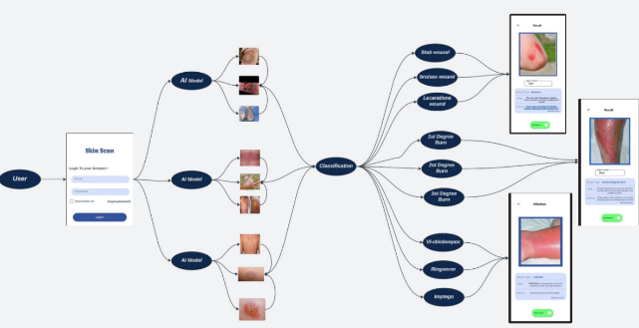**3.1 Software Architecture**

***(Fig. 1): System Architecture***

The System Architecture (Fig. 1) outlines the shape of our AI-powered wound, burn, pores and skin ‎disease analysis utility. The system is split into three key layers: User Interface, Cloud ‎Processing, and AI Models. Users interact with the app through a cell or web interface, where they ‎upload pics in their condition. These pics are securely transmitted to the cloud, wherein ‎superior AI models like EfficientNetB0 and ResNet50 carry out actual-time analysis. The ‎cloud ensures scalability, data security, and efficient processing. Once analyzed, the app affords ‎instant, correct diagnoses and actionable clinical recommendations. Additionally, users can music ‎their restoration development, talk with medical doctors, and book appointments directly via the app. This ‎complete method guarantees well-timed, dependable, and person-friendly healthcare answers for each ‎sufferer and providers.‎

**3.2 Tools and Technologies Used**

***1. Python***

* Python is the most famous language for AI and machines to get to know. It’s smooth to apply, has ‎many libraries for information processing, and works nicely with deep studying frameworks like TensorFlow.[**[23]**](https://www.turing.com/kb/python-best-adapted-to-ai-and-machine-learning)

***2. TensorFlow/Keras***

* TensorFlow is an effective deep studying framework, and Keras makes it smooth to construct ‎and educate CNN fashions. They are extensively used and feature extremely good documentation.[**[24]**](https://blog.csdn.net/qq_43279579/article/details/117298169)[**[25]**](https://www.datacamp.com/tutorial/cnn-tensorflow-python)

***3. Flutter***

* Flutter is a cross-platform framework for building cellular apps. It permits the app to ‎work on each iOS and Android with a single codebase, saving effort and time.[**[26]**](https://relevant.software/blog/top-8-flutter-advantages-and-why-you-should-try-flutter-on-your-next-project/)

***4. React.js***

* React.Js is a popular library for building web packages. It’s fast, bendy, and makes ‎it easy to create interactive person interfaces.[**[27]**](https://dev.to/coursesity/react-libraries-to-use-in-2021-15-top-picks-37d7)

***5. Kaggle Datasets***

* Kaggle gives superb, categorised datasets of scientific snap shots. These datasets had been ‎critical for schooling the CNN version to apprehend wounds, burns, and skin infections.‎

***6. Visual Studio Code (VS Code)***

* VS Code is a lightweight and effective code editor. It supports a couple of programming ‎languages and has extensions for Python, Flutter, and React.Js, making improvements less difficult.‎

***7. Git***

* Git is a version control system that helps track changes in the code. It’s essential for collaboration and ensures that the project can be managed efficiently.

***8. .NET Web API Framework***

* .NET is a strong framework for building backend structures. It changed into used to create ‎RESTful APIs that join the app with the AI model.[**[28]**](https://dzone.com/articles/aspnet-web-api-benefits-and-why-to-choose-it)[**[29]**](https://dev.to/wirefuture/how-to-build-restful-apis-with-aspnet-core-8-j5)

***9. MySQL***

* MySQL is a dependable and clean-to-use database system. It became used to keep person records, ‎app facts, and version outputs.[**[30]**](https://dev.mysql.com/doc/refman/8.4/en/what-is-mysql.html)

***10. Render***

* Render is a cloud platform for deploying apps. It’s consumer-pleasant, scalable, and ensures ‎the app can deal with many customers without performance troubles.‎

***11. Convolutional Neural Networks (CNNs)***

* CNNs are the high-quality choice for image classification obligations. They can robotically detect ‎patterns in pics, making them the best for studying wounds and burns.‎

***12. Transfer Learning***

* Transfer learning allows us to use pre-educated models (like ResNet or EfficientNet) and ‎satisfactory-tunes them for unique obligations. This saves time and improves accuracy.‎

***13. Figma***

* Figma is a design tool used to create the app’s user interface. It’s great for collaboration and prototyping.

***14. Scikit-learn***

* Scikit-learn is a library for data preprocessing and evaluation. It helps with preparing data and measuring model performance.

***15. Matplotlib/Seaborn***

* These libraries are used for data visualization. They help with analyzing model performance and understanding results.

***16. React Testing Library***

* This library is used to test the React.js front end, ensuring the web app works correctly.

***17. Flutter Testing Tools***

* Flutter has built-in tools for testing mobile apps, ensuring they work well on different devices.

***18. Docker***

* Docker is used to containerize the app, making it easier to deploy and run in different environments.

**3.3 Software Functionalities**

The **Wound Detection Using Deep Learning (CNN)** software is designed to provide a comprehensive answer for diagnosing wounds, burns, and skin infections the usage of AI. Below are the ‎key capabilities and functionalities of the software program, at the side of an evidence of the way every feature ‎contributes to solving the hassle:‎

***1. Image Upload and Analysis***

* **Problem**: Users often face delays in getting clinical interest because of the need for physical ‎visits to healthcare centers.‎
* **Feature**: Users can upload photos of their wounds, burns, or skin conditions without delay through the app.‎
* **How It Solves the Problem**: This feature allows users to quickly and without problems percentage their ‎situation with the AI version, permitting on the spot **evaluation without the want for physical ‎visits**. It saves time and provides instant feedback, reducing delays in diagnosis.‎

***2. AI-Powered Diagnosis***

* **Problem**: Manual diagnosis via healthcare professionals can **be subjective, time-‎eating, and liable to errors**, particularly in regions with restrained get admission to specialists.‎
* **Feature**: The app uses a **Convolutional Neural Network (CNN)** to investigate uploaded pics ‎and classify the condition (e.g., first-degree burn, bacterial infection).‎
* **How It Solves the Problem**: The AI model offers correct and reliable diagnoses, ‎reducing the danger of misdiagnosis and making sure steady results, even in underserved areas.‎

***3. First-Aid Recommendations***

* **Problem**: Without on-the-spot steerage, users may additionally take wrong moves that worsen their ‎situation or delay recovery.‎
* **Feature**: Based on the prognosis, the app provides **instant first-aid recommendations ‎and care commands.‎**
* **How It Solves the Problem**: This characteristic ensures customers can take **appropriate action** to ‎manage their circumstance earlier than in search of professional help, stopping complications and ‎selling quicker recuperation.‎

***4. Progress Tracking***

* **Problem:** Users often battle to screen their recovery development, which could lead to ‎behind schedule intervention if the circumstance worsens.‎
* **Feature:** Users can upload observation-up pictures to music the healing development of their wound ‎or burn over time. These snap shots are saved in a committed "History" segment within the ‎app.‎
* **How It Solves the Problem:** The app's historical feature allows users to add new ‎ snapshots of their wound or burn, which might be then displayed in chronological order. This ‎permits customers to visually compare the cutting-edge kingdom in their harm with previous stages, ‎helping them check whether the condition is enhancing or closing the same. This characteristic empowers customers to ‎take important moves, seeking medical attention, if they are aware of no improvement or a decline in their circumstance, ensuring well timed intervention.‎

***5. Doctor Consultation and Appointment Booking***

* **Problem**: Access to healthcare professionals is limited, especially in remote areas, leading to delays in receiving medical advice.
* **Feature**: The app permits customers to connect to healthcare professionals for **digital ‎consultations** or e book in-man or woman appointments.‎
* **How It Solves the Problem**: These characteristics **bridge the space** between users and healthcare ‎carriers, making sure users can get admission to professional medical advice whilst wanted, even in ‎far off areas.‎

***6. Multi-Platform Support***

* **Problem**: Many healthcare apps are restrained to a single platform, restricting accessibility for ‎customers with specific gadgets.‎
* **Feature**: The app is to be had on each cellular **(iOS/Android)** and **web platforms**.‎
* **How It Solves the Problem**: Multi-platform assist ensures customers can access the app ‎from **any device**, making it handy and handy for everyone.‎

***7. User-Friendly Interface***

* **Problem**: Complex interfaces can deter users, especially in healthcare applications where ‎simplicity is crucial.‎
* **Feature**: The app has an **easy**, **intuitive interface designed** for ease of use.‎
* **How It Solves the Problem**: A person-pleasant interface guarantees that even **non-technical ‎users** can navigate the app without problems and get admission to its functions without issue.‎

***8. Scalability and Performance***

* **Problem**: Many healthcare apps war with performance issues as user numbers develop, ‎leading to crashes or sluggish responses.‎
* **Feature**: The app is built on scalable technology like **.NET Web API** and hosted on **Render**, ‎ensuring it can take care of many users without performance issues.‎
* **How It Solves the Problem**: Scalability ensures the app stays **fast and responsive**, even ‎because the person base grows, providing an unbroken enjoyment for all users.‎

***4. METHODOLOGY***

**4.1 Data Collection and Preprocessing**

***4.1.1 Skin-Disease***

The dataset contains 8 different classes of skin infections, categorized into

1.Bacterial Infections- impetigo 2.Fungal Infections - athlete -foot

3.Fungal Infections - nail-fungus 4.Fungal Infections – ringworm

5.Parasitic Infections - cutaneous-larva-migrans 6.Viral skin infections - chickenpox

7. Viral skin infections – shingles

**Preprocessing**

1.Each image was resized to 299x299 pixels to match the input size of ResNet50 model.

2.Images were converted from BGR to RGB color space.

3.Pixel values were normalized using the ResNet50 preprocessing function to scale the data

appropriately for the model.

4.Data augmentation was applied **to** enhance the diversity of the training data and prevent

overfitting like

**a. Rotation** (up to 30 degrees) **b. Width and Height Shifts** (up to 20%)

**c. Shearing d. Zooming** (up to 30%)

**e. Brightness Adjustment** (range of 0.7 to 1.3) **f. Horizontal Flipping**

5.The class labels were encoded into numerical values using (Label Encoder) and then transformed into numerical values into one-hot encoding for multi-class classification.

**Model Development:**

I used **ResNet50 model** as the base architecture, it is pre-trained on the ImageNet dataset. It is used with its **top layers removed** (include_top=False) to allow fine-tuning for my dataset.

**Added Layers**:

1. **Global Average Pooling (GAP) Layer** reduces overfitting and extracts spatial features from the feature maps.
2. **Batch Normalization Layer:** Speeds up training and stabilizes learning by normalizing intermediate outputs
3. **Dense Layer (512, ReLU):** Captures high-level features from input data**.**
4. **Dropout (50%):** Reduces overfitting by randomly deactivating neurons during training.
5. **Final Dense Layer (8, Softmax):** Outputs class probabilities for multi-class classification.

**Architecture Diagram**

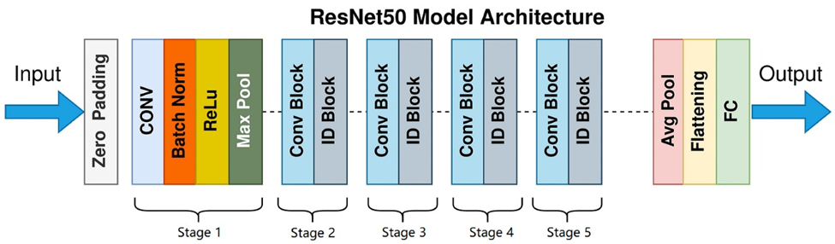

***(Fig. 2): ResNet50 Architecture Diagram***

**Model Training**

* **Optimizer:** Adam, chosen for efficient weight updates. Learning rate: 1e-4.
* **Loss Function:** Categorical cross-entropy, suitable for multi-class classification.
* **Hyperparameters**
* Batch size: 32
* Epochs: 50
* Learning rate adjustment**:** Reduced by **0.2** if validation loss plateaued.

1. **Class Weights:** Adjusted dynamically to handle class imbalance**.**
2. **Callbacks**:

**- ReduceLROnPlateau**: Lowers the learning rate by **0.2** after **3 epochs** of no improvement.

**- Early Stopping**: Stops training after **10 epochs** of no validation loss **improvement**,

restoring the best weights.

**Training Procedure**

**Data Augmentation:** Used ImageDataGenerator to apply rotation, zoom, brightness

adjustment, and flips for better generalization.

**Fine-tuning:** Last 10 layers of the ResNet50 base model were unfrozen to adapt pre-trained weights to the dataset.

***4.1.2 Burn***

The dataset contains 3 different classes of skin-burn infections, categorized into

1. 1st degree (543 image) 2. 2nd degree (488 image) 3. 3rd degree (326 image)

**Preprocessing**

1. **Dataset Download:** download burn degree images (1st, 2nd, and 3rd degree) from Kaggle.
2. **Directory Setup:** Organized images into separate subfolders for each burn degree.
3. **Data Count:** Counted images before and after augmentation to assess dataset size.
4. **Data Augmentation:** Applied transformations to enhance model robustness, including:

a. Zooming b. Shifting (horizontal & vertical)

c. Flipping (horizontal & vertical)

1. **Resizing:** set all images to **224x224 pixels** for model compatibility.
2. **Shuffling:** Ensured data randomness before training.
3. **Train-Test Split:** Divided data into **80% training** and **20% testing**.
4. **Label Encoding:** Converted labels into a categorical format for classification

**Model Development**

I used EfficientNetB**0 model** as the base architecture, which is pre-trained on the ImageNet dataset. It is used with its **top layers removed** (include_top=False) to allow fine-tuning for my dataset...

**Added Layers:**

1. **Global Average Pooling (GAP) Layer**

Summarizes spatial features and reduces overfitting by creating a condensed

representation of feature maps.

1. **Dropout Layer (50%)**

Randomly deactivates neurons during training to prevent overfitting.

1. **Fully Connected (Dense) Layer**

Outputs class probabilities for three burn degrees (1st, 2nd, and 3rd) using a softmax

activation function

**Architecture Diagram**

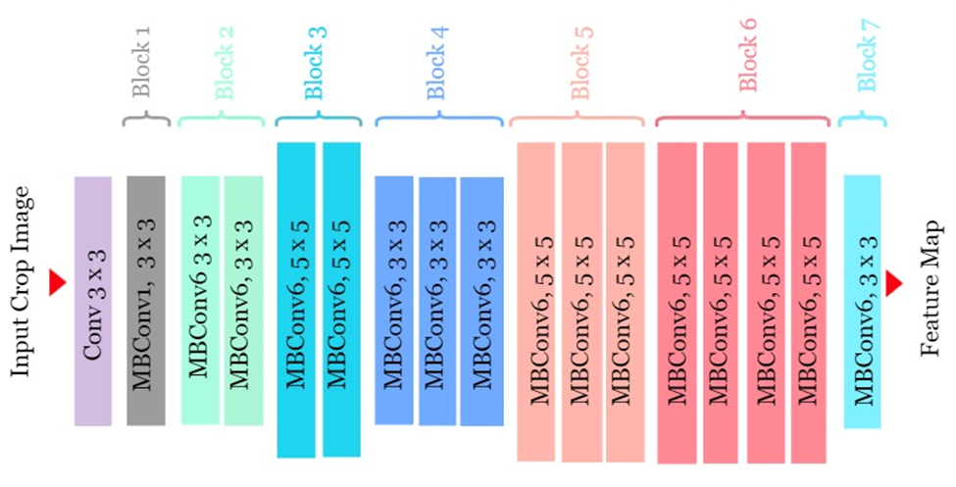

***(Fig. 3): EfficientNetB0 Architecture Diagram***

**Model Training**

**Optimizer:** Adam, chosen for its adaptive learning capabilities.

**Loss Function:** Categorical cross-entropy, suitable for multi-class classification.

**Hyperparameters:** Batch size = 32, Epochs = 65, Learning rate dynamically adjusted.

**Callbacks:**

* **ReduceLROnPlateau:** Reduced learning rate by **0.2** if validation loss plateaued for **10 epochs**.
* **EarlyStopping:** Stopped training after **10 epochs** of no improvement, restoring the best weights.
* **Model Checkpoint:** Saved the model with the lowest validation loss.

#### **Training Procedure**

**Data Augmentation:** Applied zoom, shifts, and horizontal/vertical flips using

ImageDataGenerator to improve generalization.

## 

## ***4.1.2 Wound-Type***

The dataset contains 10 different classes of skin-burn infections, categorized into:

1. Abrasions 2. Bruises 3. Burns

4. Cut 5. Diabetic Wounds 6. Laseration

7. Normal 8. Pressure Wounds 9. Surgical Wounds

10. Venous Wounds

**Preprocessing**

1. **Resizing:** Images resized to **(299, 299) pixels** for ResNet50 compatibility.
2. **Color Conversion:** Converted from **BGR to RGB** using cv2.cvtColor()
3. **Normalization:** Applied TensorFlow's preprocess_input() for proper pixel scaling.
4. **Label Encoding:** Converted wound class names into numerical values using Label Encoder.
5. **Dataset Split:** 80% training, 20% testing.

**Model Development**

I used **ResNet50 model** as the base architecture, it is pre-trained on the ImageNet dataset. It is used with its **top layers removed** (include_top=False) to allow fine-tuning for my dataset.

**Added Layers**:

1. **Global Average Pooling (GAP) Layer:** reduces overfitting and extracts spatial features from the feature maps.
2. **Batch Normalization Layer:** Speeds up training and stabilizes learning by normalizing intermediate outputs
3. **Dense Layer (512, ReLU):** Captures high-level features from input data**.**
4. **Dropout (50%):** Reduces overfitting by randomly deactivating neurons during training.
5. **Final Dense Layer (10, Softmax):** Outputs class probabilities for multi-class classification.

**Model Training**

1. **Optimizer:** Adam, chosen for its adaptive learning capabilities.
2. **Loss Function:** Categorical cross-entropy, suitable for multi-class classification.
3. **Hyperparameters**:

**a**. **Batch Size**: (32) b. **Epoch**: 50 (with early stopping)

c. **Learning Rate Scheduler**: ReduceLROnPlateau was used to

reduce the learning rate when validation loss plateaued.

1. **Class Weights**: We used it to handle class imbalance in the dataset
2. **Callbacks**:
   1. **Early Stopping** Stopped training after 10 epochs of no improvement in validation loss.
   2. **ReduceLROnPlateau**: Reduced learning rate by 0.2 if validation loss stagnated for 3 epochs.

***Training Procedure***

The training process involved dataset splitting, data augmentation, fine-tuning the last 10 layers of ResNet50, handling class imbalance with computed class weights, using EarlyStopping and ReduceLROnPlateau to prevent overfitting, and training for 50 epochs with final weights saved.

## ***4.1.3 wound segmentation***

* The dataset consists of wound images and their corresponding segmentation masks. The images are RGB, while the masks are grayscale, where pixel values represent the presence (1) or absence (0) of a wound.
* The dataset consists of a Training set: 2,208 images and masks and Testing set: 552 images and masks.

### **Preprocessing**

1. **File Path Retrieval**: Retrieves and sorts of image and mask file paths from directories.
2. **Dataset Validation**: Ensures the number of images matches the number of masks to prevent training mismatches.
3. **Image and Mask Preprocessing**

Images:

a. Loaded in RGB format. b. Resized to a fixed size of (256, 256).

c. Normalized to the range [0, 1] by dividing pixel values by 255.

Masks:

a. Loaded in grayscale. b. Resized too (256, 256).

c. Channel dimension expanded. d. Normalized to the range [0, 1].

1. **In Data Augmentation**: we are applied:
   1. Random horizontal and vertical flips.
   2. Random rotations within a range of [-15°, 15°].

### ***4.1.4. Model Segmentation***

**We use a U-Net model, it’s** a special type of neural network used for semantic segmentation (labeling each pixel in an image).

* **Encoder**: Shrinks the image to find important features using convolutional layers, batch normalization, dropout, and max pooling.
* **Bridge**: The middle part (bottleneck) connects the encoder and decoder, with many filters to process detailed features.
* **Decoder**: Expands the image back to its original size using transposed convolutions and combines features from the encoder for better results (skip connections).
* **Output Layer**: A final layer with a sigmoid activation to create a binary segmentation map (pixels labeled as 0 or 1).

**Architecture Diagram**

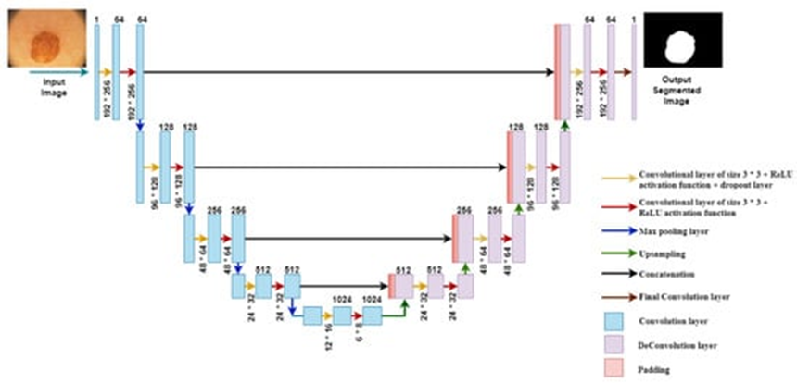

***(Fig. 4): U-Net model Architecture Diagram***

#### **Training Process**

* **Loss Function**: Binary cross-entropy is used to measure the difference between predicted and ground truth masks.
* **Optimizer**: Adam optimizer with a learning rate of 1e-4.
* **Evaluation Metrics**: Accuracy and Intersection over Union (IoU) are used to evaluate model performance.
* **Hyperparameters**:
  + Batch size: 16
  + Epochs: 50
  + Dropout rates: Vary between 0.1 and 0.3 across layers.
* **Callbacks**:
  + Early stopping to prevent overfitting.
  + Learning rate reduction on plateau.
  + Model checkpointing to save the best model.

**4.2. Implementation**

***4.2.1 UI/UX***

* For Mobile App: A responsive, intuitive design crafted for easy navigation and optimal usability. The app ensures an engaging experience for users of all technical skill levels.
* For Website: The online interface offers a simple file upload mechanism, a button to submit the image for processing, and a section to display the categorization results, allowing for easy interaction with the system.

***4.2.2 Mobile Application (SW Package) and Website***

The mobile application and web interface for identifying burn and wound photos were developed using user-friendly platforms that allowed for easy interaction with the model and effective display of results.

**AI-based Diagnosis:** A module powered by deep learning models to analyse uploaded images of wounds, burns, and bacterial skin infections. This feature provides instant diagnoses with accuracy rates of up to 98%, ensuring reliable results for users and medical professionals alike.

**Communication System**: Seamless integration of chat and consultation features, connecting users with specialized doctors in real-time. This feature supports efficient communication, empowering users to get timely medical advice.

**Appointment Booking and Doctor Interaction Feature:** The web interface allows users to access a list of burns and wounds specialists, connect with them through the system, and book appointments directly. The interface also includes information about the doctors' expertise and working hours.

***4.2.3 Backend Integration***

The backend service, which handles uploaded photos and communicates with the machine learning model, was built with Flask.

API Endpoints: RESTful endpoints were established to accept incoming queries, upload photos, and return categorization results in the JSON format.

Model Integration: The backend loads the pre-trained model and processes the supplied images to ensure they meet the model's input criteria. Predictions are made, and the most likely classification is returned.

This implementation focuses on providing consistent user experience across mobile and online platforms while maintaining accurate communication with the machine learning model stored on the backend server. It also makes it easier to contact doctors and schedule appointments, resulting in a more comprehensive and integrated experience.

# ***5.*** ***RESULTS AND DISCUSSION***

## **Comparison among the results of our models**

|  |  |  |  |  |  |
| --- | --- | --- | --- | --- | --- |
| **Dataset** | **Model** | **Accuracy** | **Precession** | **Recall** | **F1-score** |
| Skin_Disease | **ResNet50** | 97% | 97% | 97% | 97% |
| Wound_Type | **ResNet50** | 97% | 97% | 97% | 97% |
| Skin_Burn | EfficientNetB0 | 95% | 95% | 95% | 95% |
| Wound_seg | U-Net | 99% | 86% | 87% | 87% |

## **Skin-Disease**

***(Fig. 5): Accuracy, Precision, Recall, and F1-Score (Fig.6): Training and validation loss and accuracy***

## **Skin-Burn**

صورة تحتوي على نص, لقطة شاشة, رسم بياني, مستطيل

تم إنشاء الوصف تلقائياً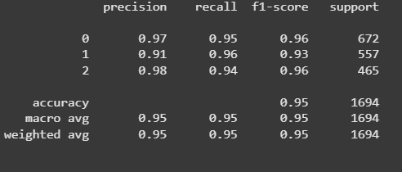

***(Fig. 7): Accuracy, Precision, Recall, and F1-Score (Fig. 8): Confusion Matrix***

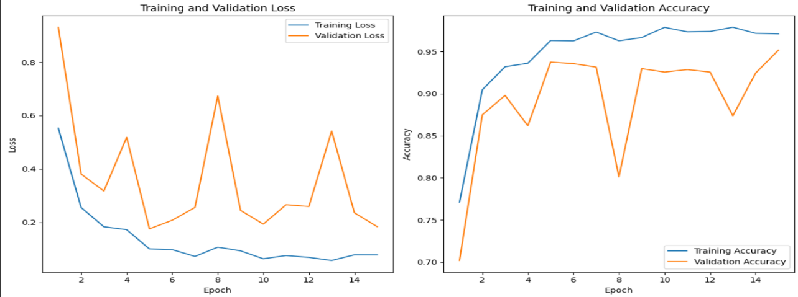

***(Fig. 9): Training and validation loss and accuracy***

## **Wound-Type**

صورة تحتوي على لقطة شاشة, خط, تخطيط, نص

تم إنشاء الوصف تلقائياً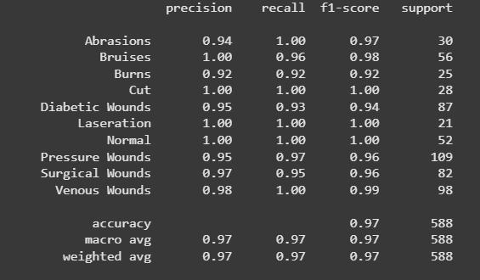

***(Fig. 10): Accuracy, Precision, Recall, and F1-Score (Fig. 11): Training and validation loss and accuracy***

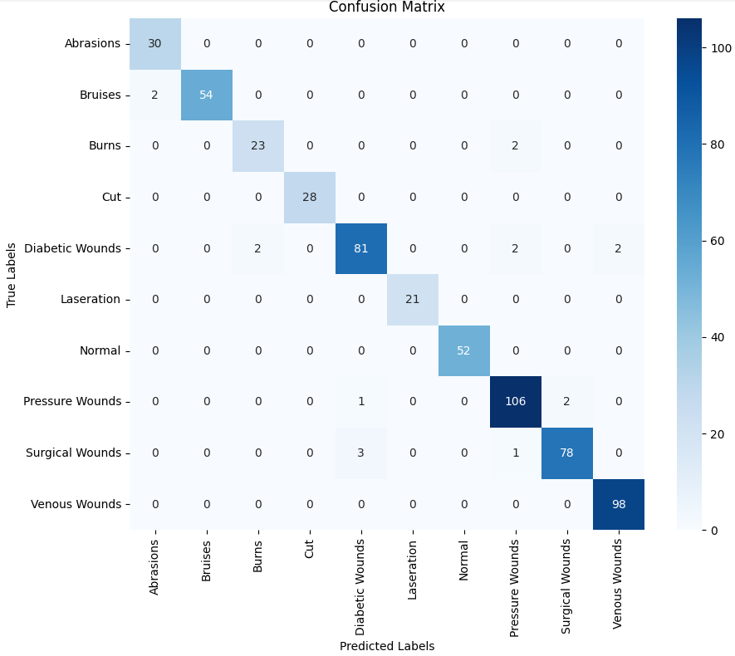

***(Fig. 12): Confusion Matrix***

**Wound segmentation**

صورة تحتوي على شخص, لقطة شاشة, إسعافات أولية

تم إنشاء الوصف تلقائياً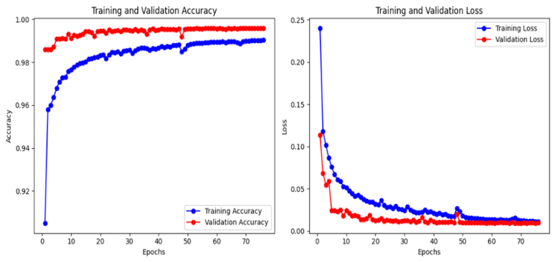

***(Fig13): Training and validation loss and accuracy (Fig. 14): Simple image and masks***

***6. ILLUSTRATIVE EXAMPLES***

|  |  |
| --- | --- |
|  |  |

|  |  |  |  |
| --- | --- | --- | --- |
| |  |  |  | | --- | --- | --- | | ***(Fig.15) Create an account or log in to an existing one: The user can create a new account by clicking on the sign-up button. Or can log in to an existing one by entering the email and password of the user then click on log in button.*** |  | ***(Fig.16) The page is the main menu of the Skin Scan app, displaying options like About Us, Browse Disease, Feedback, Doctors, and Logout. It also features a navigation bar with home, scan, and settings icons.*** | |

|  |  |
| --- | --- |
|  |  |

|  |  |  |
| --- | --- | --- |
| ***(Fig.17) The home page displays recent analysis results and allows users to capture and analyze wound or burn images using the AI model. It also provides access to settings via the website.*** |  | ***(Fig.18) The result page analyzes the captured wound or burn image by selecting an AI model. It displays the classification, risk of complications, and details on the injury's cause and nature.*** |

|  |  |
| --- | --- |
|  |  |

|  |  |  |
| --- | --- | --- |
| ***(Fig.19) The "Type Diseases" section lists classified skin conditions and infections. Selecting a condition opens a detailed page with its description, causes, and first aid guidelines.*** |  | ***(Fig.20) The page provides details on first-degree burns, explaining their causes, including heat, electricity, and chemicals. It also offers first aid guidelines, such as cooling with water, avoiding ointments, and monitoring for shock.*** |

***7. IMPACT***

***7.*1 Target Audience‎**

***1. General Public (Individuals with Wounds, Burns, or Skin Infections)***

* **Who They Are**: Everyday users who may enjoy minor to slight wounds, burns, or ‎pores and skin infections and want instant guidance.‎
* **How It Addresses Their Needs**:
  + Provides immediate, AI-powered diagnoses without the desire to visit a healthcare facility.‎
  + Offers first-resource tips to help users manipulate their situation effectively.

***2. People in Remote or Underserved Areas***

* **Who They Are**: Individuals living in rural or underserved areas with restricted get admission to healthcare facilities or professionals.‎
* **How It Addresses Their Needs**:
  + Enables faraway analysis and consultation, decreasing the want travel to distant ‎healthcare centers.‎
  + Provides get entry to professional medical advice via virtual consultations.‎
  + Acts as a primary source of healthcare, in regions with a scarcity of ‎clinical resources.‎

***3. Healthcare Professionals (Doctors, Nurses, Clinics)***

* **Who Are:** Medical specialists who can use the app as a tool to assist in ‎diagnosing and coping with patient conditions.
* **How It Addresses Their Needs:**
  + **Diagnostic Aid:** Serves as a diagnostic aid, supporting professionals speedy examining and prioritizing cases, particularly in busy environments.
  + **Workload Reduction:** Reduces the workload on healthcare systems by using handling ‎minor instances via the app, permitting experts to awareness of extra important ‎sufferers.‎
  + **Outpatient Clinics:** Allows outpatient clinics to streamline their operations with the aid of ‎enabling patients to book appointments at once through the app, lowering ‎administrative burdens and improving performance.‎

***4. Emergency Responders and First Aid Providers***

* **Who They Are**: Paramedics, first responders, and first aid providers who want quick gear to ‎assess and control injuries in emergency situations.‎
* **How It Addresses Their Needs**:
  + Offers fast analysis and first-aid suggestions, supporting responders make ‎knowledgeable decisions instantaneous.‎
  + Tracks patient progress, ensuring follow-up care is provided when needed.

***5. Travelers and Outdoor Enthusiasts***

* **Who They Are**: People who travel frequently or engage in outdoor activities (e.g., hiking, camping) may face injuries in remote locations.
* **How It Addresses Their Needs**:
  + Offers a portable, on-the-go solution for diagnosing and managing wounds or burns.
  + Provides first-aid recommendations, ensuring users can take immediate action even in remote areas.

***6. Schools and Educational Institutions***

* **Who They Are**: Schools, colleges, and universities that need tools to manage minor injuries on campus.
* **How It Addresses Their Needs**:
  + Provides a quick and reliable way to assess and manage student injuries.
  + Reduces the need for frequent visits to healthcare facilities, saving time and resources.

**7.2 Innovative Aspects of the Design**

The Wound Detection Using Deep Learning (CNN) project introduces innovative features to enhance healthcare accessibility and efficiency:

* **AI-Powered Diagnosis Using CNN**: Uses CNNs to analyze wound images, providing instant, accurate diagnoses, reducing human error, and speeding up treatment compared to manual methods.
* **Multi-Platform Accessibility**: Built with Flutter (mobile) and React.js (web), ensuring seamless use across devices, unlike single-platform apps, making it more inclusive.
* **Transfer Learning Integration**: Leverages pre-trained models like ResNet and EfficientNet, achieving high accuracy with less data and training time, making it efficient and cost-effective.
* **Scalable Backend**: Uses .NET Web API and Render for hosting, ensuring reliable performance even with many users, addressing scalability issues in other apps.
* **User-Friendly Interface**: Features an intuitive design with Flutter, making it easy for non-technical users, improving accessibility and adoption rates.
* **Personalized First-Aid Recommendations**: Provides tailored advice based on AI diagnosis, offering more relevant guidance than generic solutions.
* **Virtual Consultation and Booking**: Enables remote doctor consultations and seamless appointment booking, reducing delays in care compared to traditional systems.

**7.3 Added Value**

1. **For Users**: Provides instant, accurate diagnoses and first-aid recommendations, making healthcare accessible and affordable, especially in remote areas.
2. **For Researchers**: Advances AI in healthcare, encourages collaboration, and validates real-world AI applications.
3. **For Healthcare Industry**: Reduces workload, improves diagnostic accuracy, integrates telemedicine, and saves costs.
4. **Emergency Response**: Helps first responders assess and manage injuries quickly in emergencies.
5. **Schools/Workplaces**: Offers on-the-spot first aid for minor injuries, reducing healthcare visits.
6. **Travel/Outdoor Use**: Ideal for travelers and outdoor enthusiasts needing immediate guidance in remote locations.
7. **Future Applications**: Can expand to diagnose other conditions (e.g., rashes, skin cancer) and integrate with wearable devices.
8. **Global Impact**: Potential for multilingual support and partnerships with healthcare providers to scale the app globally.

***8. CONCLUSIONS***

The development of this modern virtual application, powered by artificial intelligence, marks a ‎transformative step in healthcare accessibility and performance. By leveraging superior deep learning ‎fashions, the application presents customers with fast, correct, and dependable diagnoses for burns, wound ‎sorts, and bacterial skin infections. This assignment now not handiest addresses important gaps in healthcare ‎get admission to however additionally empowers people to take manipulation in their health through present day ‎era. Below is a comprehensive summary of the assignment, its methodologies, and its impact.‎ The app changed into designed with personal convenience and healthcare efficiency in thoughts, imparting a variety of ‎key features. Users can add pictures for fast analysis and receive quick, correct diagnoses ‎via AI-powered diagnostics. When uploading a photograph, the user can specify whether they want ‎to become aware of the type of wound, discover the call of a pores and skin ailment because of a bacterial infection, or ‎decide the degree of a burn. Based on the uploaded picture, the AI model will offer the ‎corresponding effects. Additionally, the app shows important first resource measures and assesses the ‎severity of the situation primarily based on the version's outputs.‎ Furthermore, the app allows users to communicate at once with a specialized physician concerning their ‎circumstance. Users can ship the image they need to be tested through a non-public chat with the doctor ‎inside the app. They can also eBook an appointment with the identical health practitioner, making it easier to get the right of entry to ‎professional healthcare steering. The appointment reserving characteristic streamlines the manner of scheduling ‎medical consultations, reducing delays in receiving care and ensuring well timed intervention.‎ For wound type classification, the application employs Resnet50 to categorize six types of wounds. By incorporating class weighting to address data imbalance, the model achieved test accuracy of 92.66% and a final validation accuracy of 96%, showcasing its reliability in real-world applications. This ensures fair representation of all wound types and enhances the model's diagnostic capabilities. In the case of pores and skin disease prognosis, the utility uses ResNet50 to detect eight forms of ‎bacterial skin infections. Advanced preprocessing techniques and fine-tuning were employed to ‎enhance model performance, resulting in an impressive test accuracy of 97%. The model demonstrated high precision and remembered throughout all disease categories, ensuring accurate and reliable ‎diagnoses.‎ The application addresses several critical challenges in healthcare delivery. It bridges the gap in healthcare access, particularly in remote and underserved areas, by providing a tool for rapid and accurate diagnosis. By handling minor cases, it reduces the burden on healthcare systems, allowing medical professionals to focus on critical situations. Early and accurate diagnosis minimizes the risk of severe complications, improving patient outcomes. Additionally, the application assists in prioritizing cases during emergencies, optimizing resource allocation and response times.

‎ In the end, this project is not just a technological achievement but a **step toward a future** where healthcare is more **accessible, efficient, and effective** for everyone.

***9. FUTURE DIRECTIONS***

* Integration with medical devices: In the future, the application can be integrated with wearable medical devices to continuously monitor wounds and burns.
* Add a feature to track wound healing progress by uploading sequential images
* Identify bacteria: Develop a model that predicts bacterial infection from wound images
* Alert users if self-medications (e.g., ointments) conflict with their medical history.
* Multiple language support: Add local languages to serve remote areas.
* Partnerships with pharmaceutical companies

***10. REFERENCES***

1. *world’s population and cause serious health complications*
2. <https://almoosahealthgroup.org/ar/article/%D8%AA%D8%B4%D8%AE%D9%8A%D8%B5-%D8%A3%D9%85%D8%B1%D8%A7%D8%B6-%D8%A7%D9%84%D8%AC%D9%84%D8%AF/>
3. *treating chronic wounds:* <https://pubmed.ncbi.nlm.nih.gov/31481277/>
4. *Burns deaths worldwide:* <https://www.uoc.edu/en/news/2025/an-ai-powered-app-to-diagnose-skin-related-neglected-diseases-has-shown-promising-results>
5. Chronic wounds become infected:

<https://almoosahealthgroup.org/ar/article/%D8%AA%D8%B4%D8%AE%D9%8A%D8%B5-%D8%A3%D9%85%D8%B1%D8%A7%D8%B6-%D8%A7%D9%84%D8%AC%D9%84%D8%AF/>

1. *Krittanawong, C., Zhang, H., Wang, Z., Aydar, M., & Kitai, T. (2020*). Artificial intelligence in precision cardiovascular medicine. Journal of the American College of Cardiology, 76(11), 1318-1335.
2. *Segmentation and classification of skin burn images with artificial intelligence* <https://www.sciencedirect.com/science/article/abs/pii/S0305417924000135>
3. *A deep convolutional neural network-based approach for detecting burn severity from skin burn images* <https://www.sciencedirect.com/science/article/pii/S2666827022000639>
4. *Real-time burn depth assessment using artificial networks* [https://www.sciencedirect.com /science/article/abs/pii/S0305417920304691](https://www.sciencedirect.com/science/article/abs/pii/S0305417920304691)
5. *Wound image evaluation with machine learning* [https://www.sciencedirect.com/science /article/abs/pii/S0925231215002945](https://www.sciencedirect.com/science/article/abs/pii/S0925231215002945)
6. *Validating Wound Severity Assessment via Region-Anchored Convolutional Neural Network* <https://pmc.ncbi.nlm.nih.gov/articles/PMC10529166/>
7. *Superficial Wound Classification Using CNN Image Classifier for Initial Wound Care* <https://ieeexplore.ieee.org/document/10730130>
8. *Systematic review of deep learning image analyses for the diagnosis and monitoring of skin disease* <https://www.nature.com/articles/s41746-023-00914-8>
9. *Artificial Intelligence Application in Diagnosing, Classifying, Localizing, Detecting and Estimation the Severity of Skin Condition in Aesthetic Medicine* [https:// onlinelibrary.wiley.com/doi/epdf/10.1002/der2.70015](https://onlinelibrary.wiley.com/doi/epdf/10.1002/der2.70015)
10. *Shallow Convolutional Neural Network Configurations for Skin Disease Diagnosis* <https://link.springer.com/chapter/10.1007/978-3-031-46573-4_34>
11. *burn dataset* <https://www.kaggle.com/datasets/faresabbasai2022/burn-dataset>
12. *Wound Images Dataset* <https://www.kaggle.com/datasets/ibrahimfateen/wound-classification>
13. *Wound images segmentation* <https://www.kaggle.com/datasets/leoscode/wound-segmentation-images>
14. *Skin-Disease-Dataset* <https://www.kaggle.com/datasets/subirbiswas19/skin-disease-dataset>
15. *Application source code*
16. *Website source code*